**Migration guidelines for configuring OSM to Istio**

**Lists of Contents**

1. Sample Bookstore application with OSM Enabled
2. Disable of OSM from the Existing application.
3. Enable Istio for the Existing Application
4. Rollback plan for Istio to OSM

**1. Sample Bookstore application with OSM Enabled.**

A sample bookstore application is deployed on to the AKS cluster with OSM Enabled.

**Namespaces**:

**Verify the OSM installed.**

az aks show --resource-group myResourceGroup

--name myAKSCluster

--query 'addonProfiles.openServiceMesh.enabled'



**Sample Application End Point:**

**2. Disable of OSM from the Existing sample application.**

**Disable the OSM add-on from your cluster: -**

* Disable the OSM add-on from your cluster using the [az aks disable-addon](https://learn.microsoft.com/en-us/cli/azure/aks" \l "az_aks_disable_addons) command and the --addons parameter.

az aks disable-addons \

--resource-group myResourceGroup \

--name myAKSCluster \

--addons open-service-mesh

**Output:**

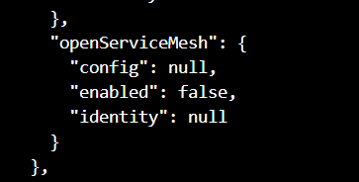

* **Verify the OSM installed:**

az aks show --resource-group myResourceGroup

--name myAKSCluster

--query 'addonProfiles.openServiceMesh.enabled'



**All the OSM related Pods, deployment replica sets got deleted.**

**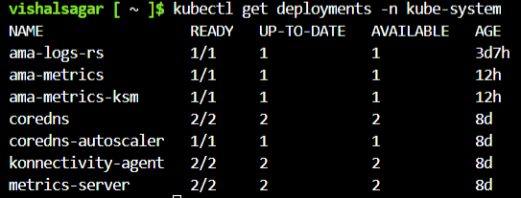**

**Note:**

If we delete the namespaces the resources under it, such as deployment, pods, service, ingress, configmap will get deleted.

1. **Enable Istio for the Existing Application**

* **Install Istio add-on for existing cluster.**

To install the Istio add-on when creating the cluster, use the --enable-azure-service-mesh or--enable-asm parameter**.**

az aks mesh enable --resource-group ${RESOURCE\_GROUP} --name ${CLUSTER}

* **Verify the Istio successfully installed:**

az aks show

--resource-group ${RESOURCE\_GROUP}

--name ${CLUSTER}

--query 'serviceMeshProfile.mode'

****

* **Add a namespace label for Istio sidecar injection: -**

kubectl label namespace bookstore istio-injection=enabled

kubectl label namespace bookbuyer istio-injection=enabled

kubectl label namespace bookthief istio-injection=enabled

kubectl label namespace bookwarehouse istio-injection=enabled

### **Deploy the Istio Virtual Service and Destination Rule for Bookstore:**

As mentioned earlier in the Bookstore Modification section, Istio handles traffic shifting utilizing a VirtualService weight attribute we configure later in the walk-through. We deploy the virtual service and destination rule for the bookstore service. We deploy only the bookstore version 1 even though the bookstore version 2 is deployed.

kubectl apply -f - <<EOF

# Create bookstore virtual service

apiVersion: networking.istio.io/v1alpha3

kind: VirtualService

metadata:

name: bookstore-virtualservice

namespace: bookstore

spec:

hosts:

- bookstore

http:

- route:

- destination:

host: bookstore

subset: v1

---

# Create bookstore destination rule

apiVersion: networking.istio.io/v1alpha3

kind: DestinationRule

metadata:

name: bookstore-destination

namespace: bookstore

spec:

host: bookstore

subsets:

- name: v1

labels:

app: bookstore

version: v1

- name: v2

labels:

app: bookstore

version: v2

EOF

* To view these resources on your cluster, run the following commands:

kubectl get pods,deployments,serviceaccounts -n bookbuyer

kubectl get pods,deployments,serviceaccounts -n bookthief

kubectl get pods,deployments,serviceaccounts,services,endpoints -n bookstore

kubectl get pods,deployments,serviceaccounts,services,endpoints -n bookwarehouse

* Sample application with Istio service Mesh.

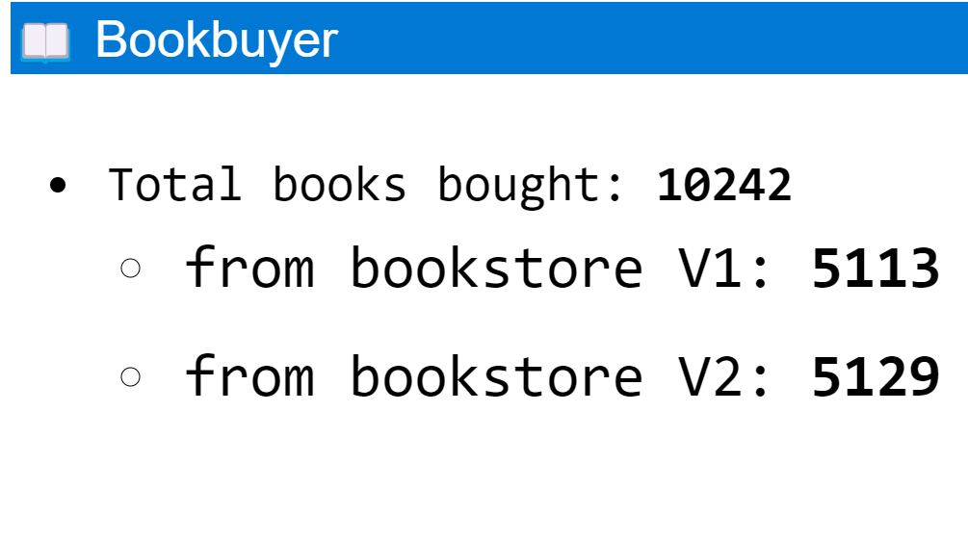

**4. Rollback plan for Istio to OSM**

1.Uninstallation of Istio from the cluster

* To completely uninstall Istio from a cluster, run the following command:
  + $ istioctl uninstall –purge

2. Disable the azure service mesh from Existing cluster

* The following command disables the Azure service mesh and delete all the namespaces in the existing cluster.

az aks mesh disable --resource-group ${RESOURCE\_GROUP} --name ${CLUSTER}

* Verify Istio is successfully uninstalled.

az aks show --resource-group ${RESOURCE\_GROUP} --name ${CLUSTER} --query 'serviceMeshProfile.mode'



## 3. Enable OSM add-on on your Existing cluster:

## The below command Enables the Open-service-mesh in the existing cluster.

az aks enable-addons \

--resource-group myResourceGroup \

--name myAKSCluster \

--addons open-service-mes**h**

* Verify OSM is successfully installed.

## 